TASKS ON S3 (Simple Storage Service)

1. Create an S3 bucket and upload some objects to S3.

PURPOSE: The purpose of creating an S3 bucket and uploading objects is to store, manage and access data securely and durably in AWS cloud storage.

OBJECTIVE: The objective of this task is to create an Amazon S3 bucket and upload objects to it.

PREREQUISITES:
- AWS account
- If you are a IAM user then u should have the permissions related S3 service
- Bucket naming plan.

OUTCOME: An Amazon S3 bucket will be created and will have the uploaded objects.

STEP BY STEP IMPLEMENTATION:
- Go to S3 service in AWS.

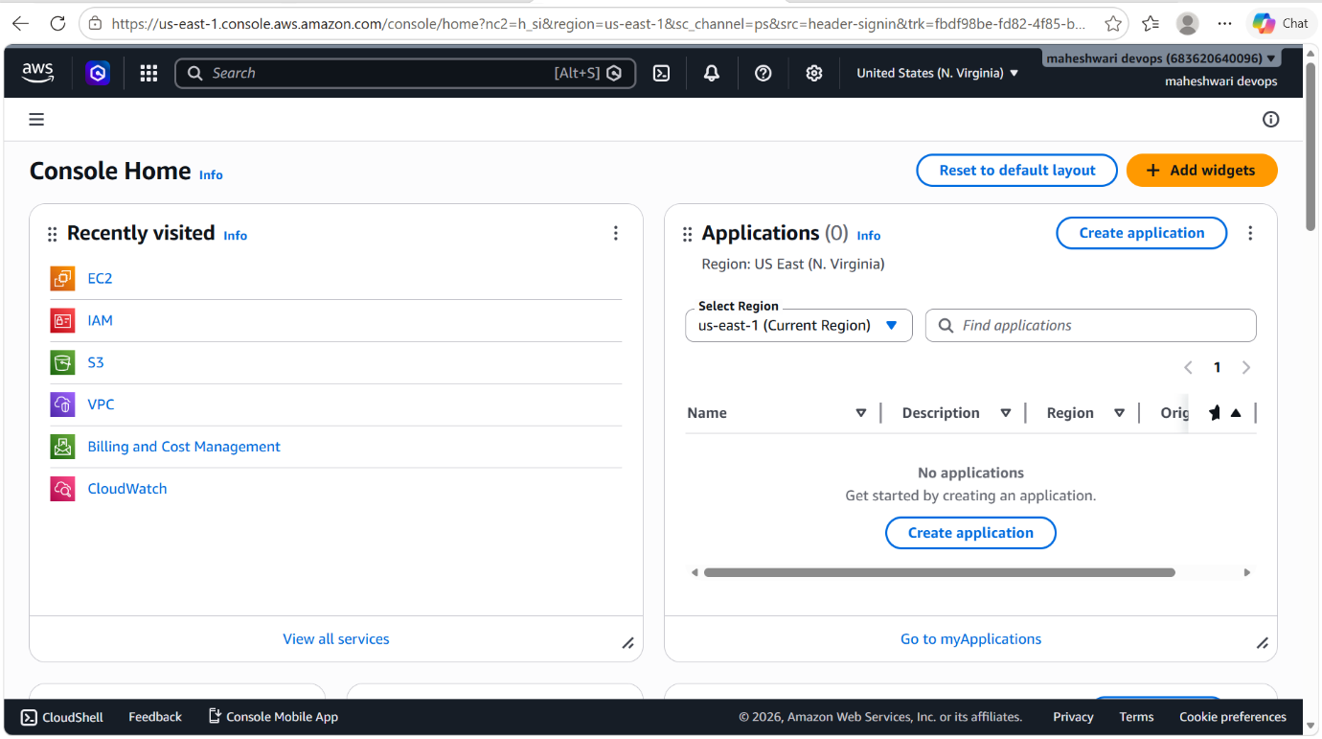
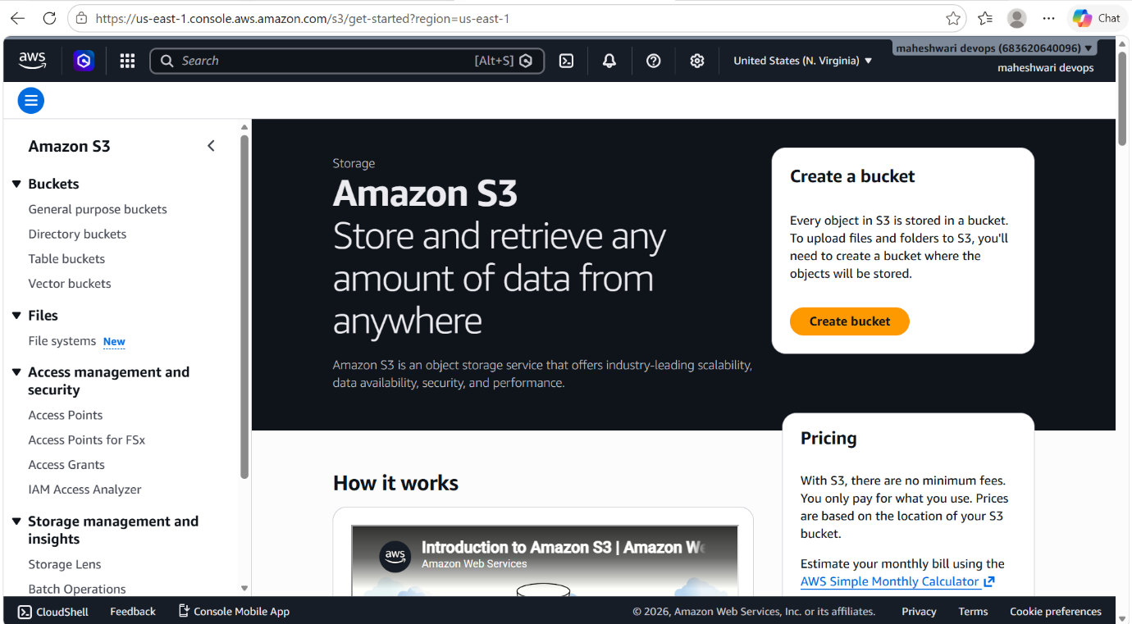

- Click on create bucket, it will navigate you to the S3 bucket creation page.
- Give the name to the bucket and must be unique otherwise AWS will throw error.
- Set ACLs enabled to make it access for everyone otherwise set it as disabled.
- It will ask for block access, it will have many options that how to give access to whom about read, write and execute permissions.
- Then click on create bucket and it will create S3 bucket for us.

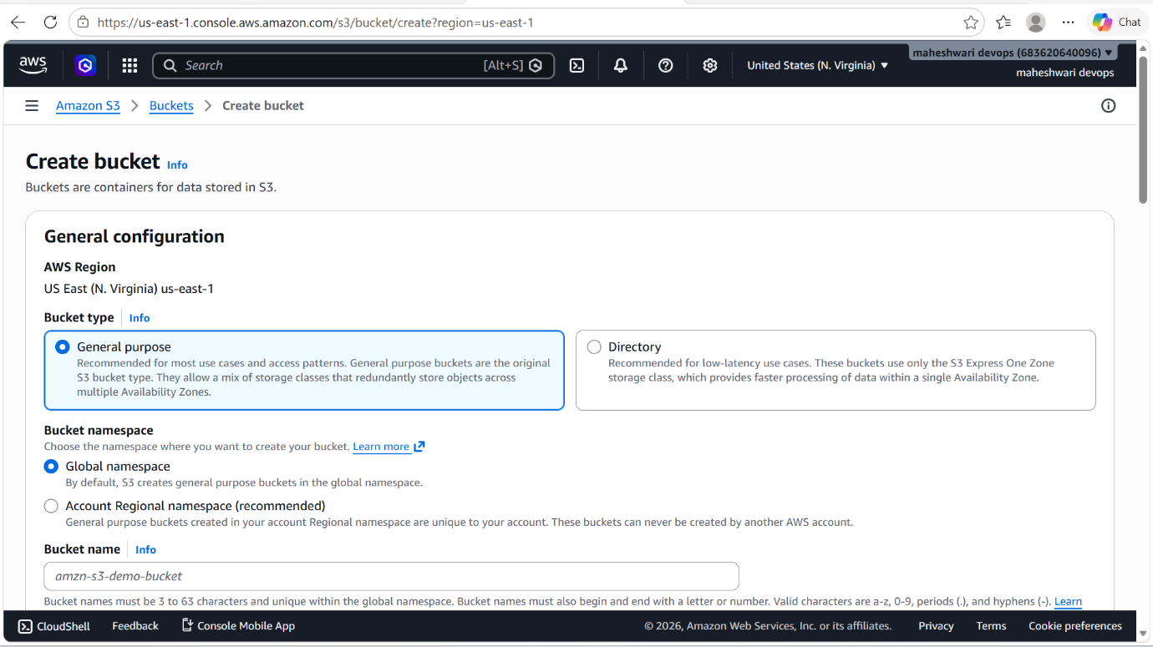

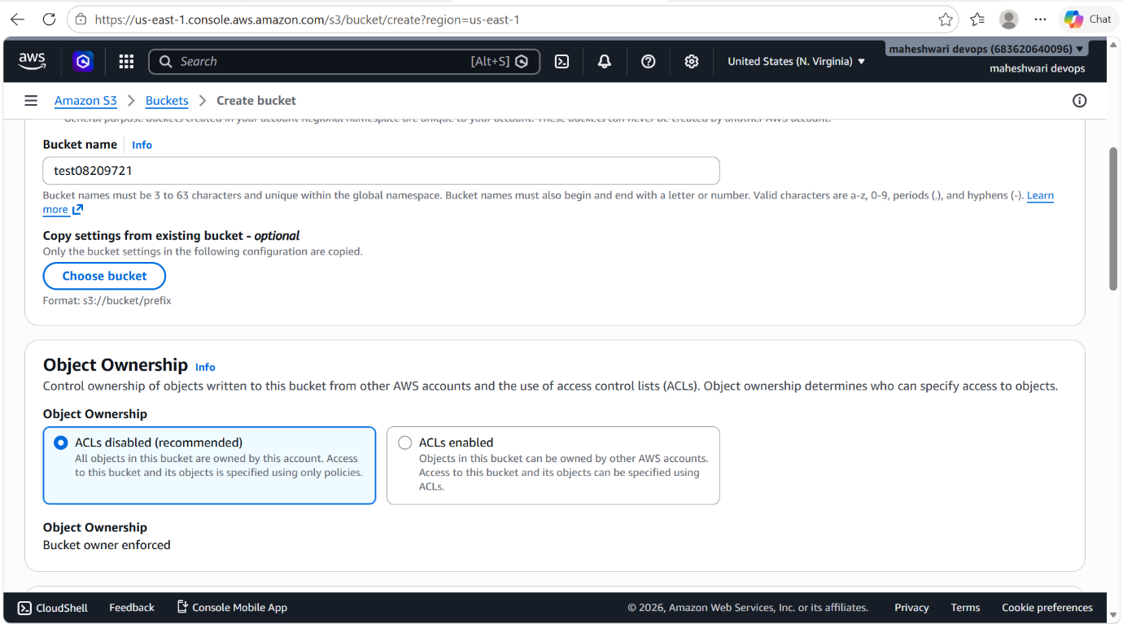

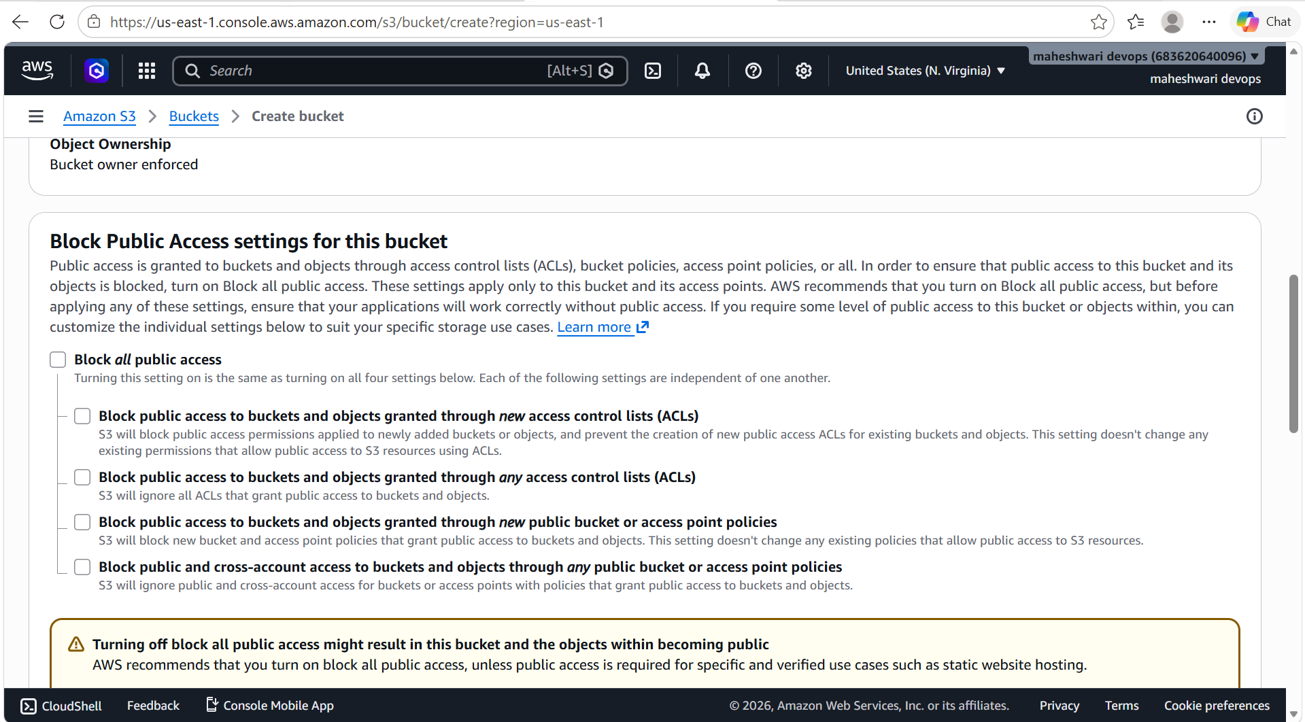

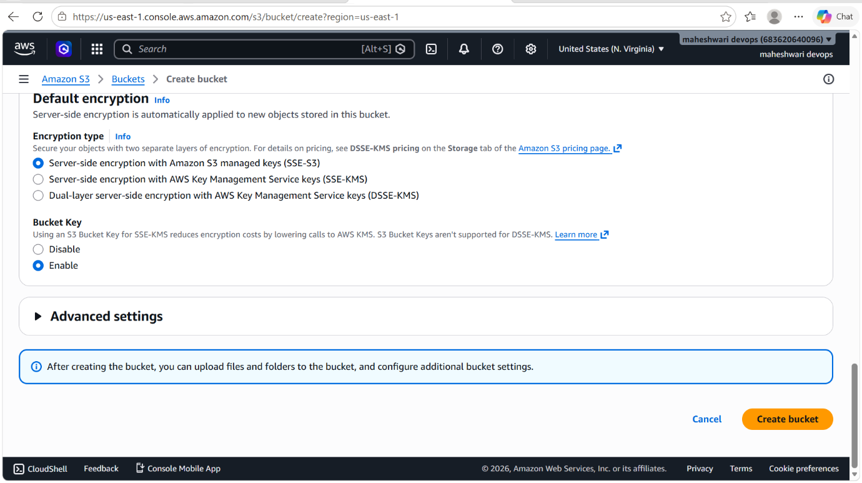

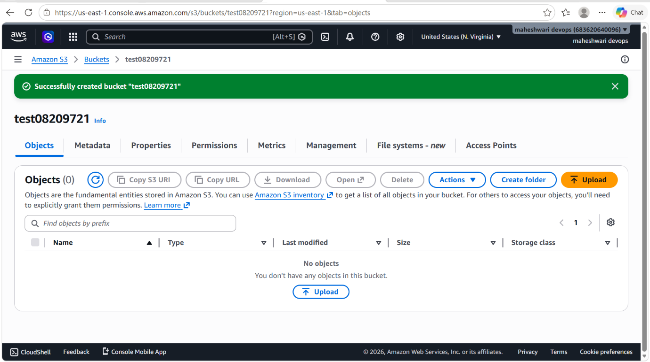

- To upload objects to our bucket then click on upload and add files that you want to upload.
- Then click on upload and it will upload our files into the S3 bucket.

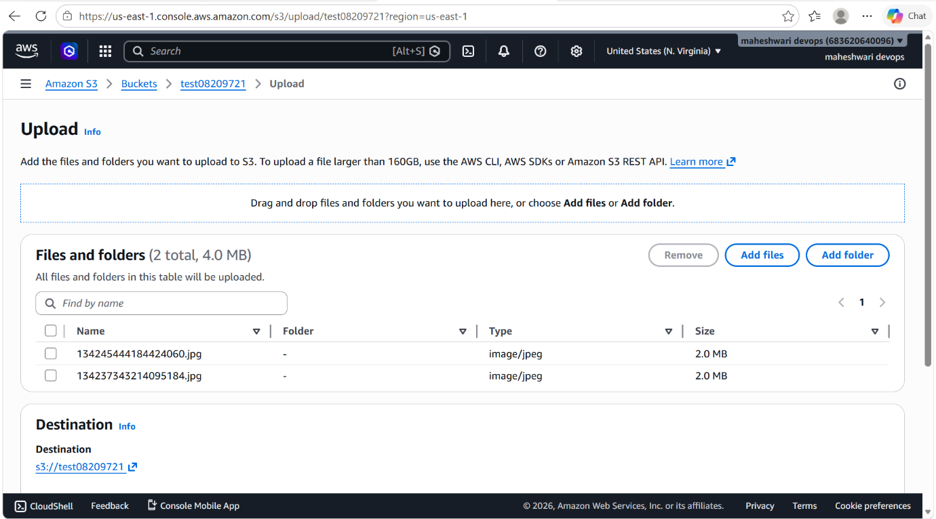

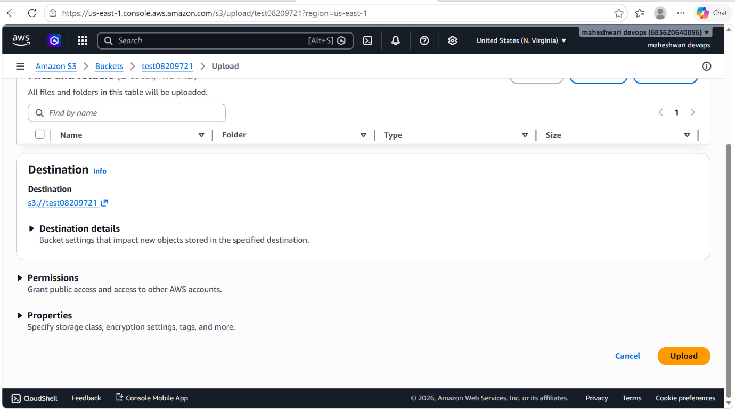

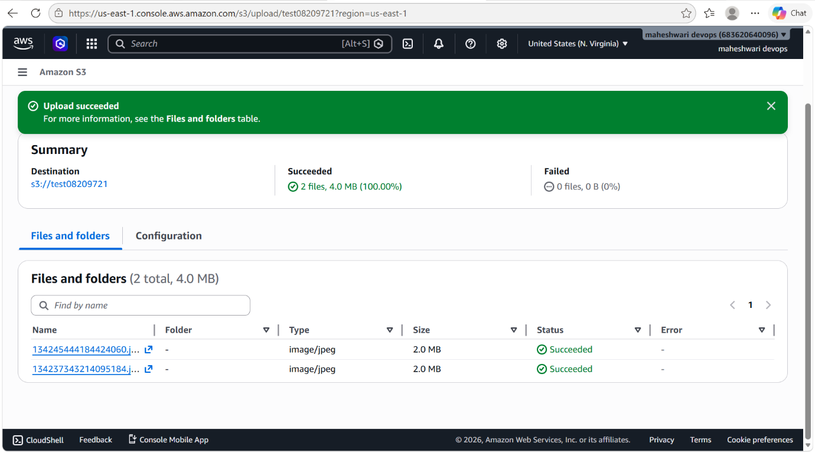

- now anyone can access my S3 objects by just copying the object url and paste it on the browser.
- There you can see the object.
- Every object will have object url.

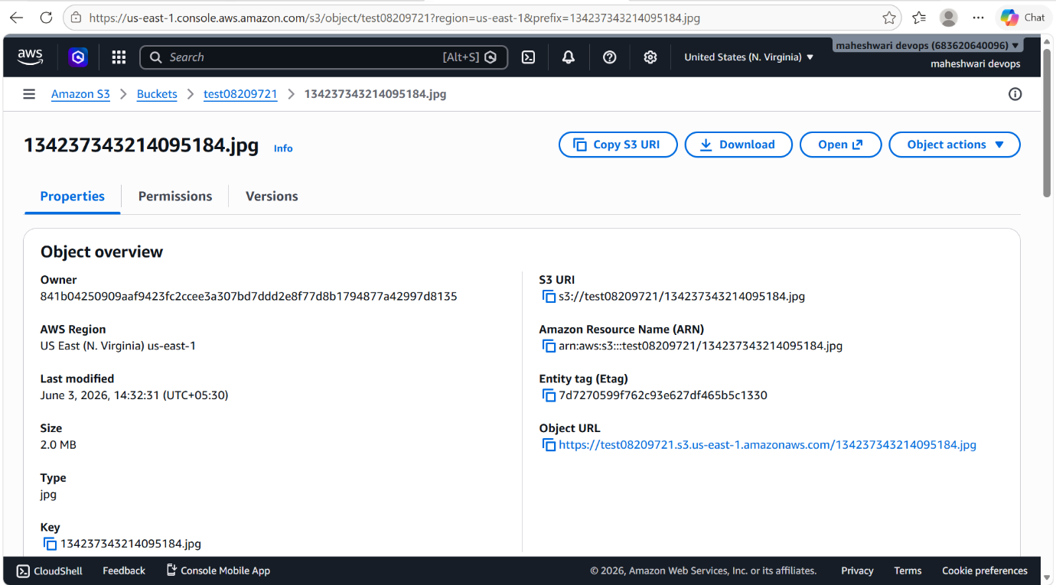

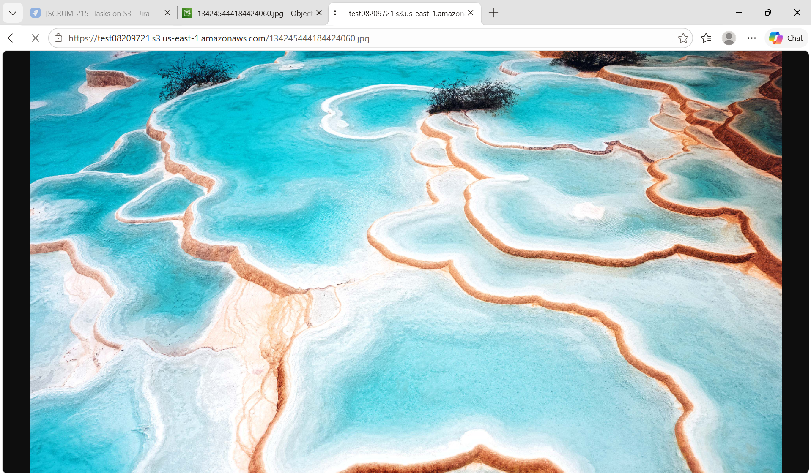

2. Deploy a static website in the S3 bucket.

PURPOSE: The purpose of deploying a static website in an S3 bucket is to host and serve web content such as HTML, CSS, JavaScript, Images and other static files directly from Amazon S3 without the need for a web server.

OBJECTIVE: To host and make a static website publicily accessible by configuring Amazon S3 static website hosting, uploading website files and setting the appropriate permissions and policies.

OUTCOME: A fully functional static website is successfully hosted on Amazon S3 and accessible to user through public website URL, demonstrating the use of AWS S3 for static web hosting.

STEP BY STEP IMPLEMENTATION:
- Go to properties of the S3 bucket and then when you scroll down you will get to see that host static website.
- That option you have to select and give the names of the files like index.html and error.html.
- Now add the objects of the static website and one more thing the names of objects should be match to file names that we have given to the static website host properties.
- After uploading, we can access that static website by the url that have created when we have enabled the host static website.
- That will be in properties pane of the S3 bucket.

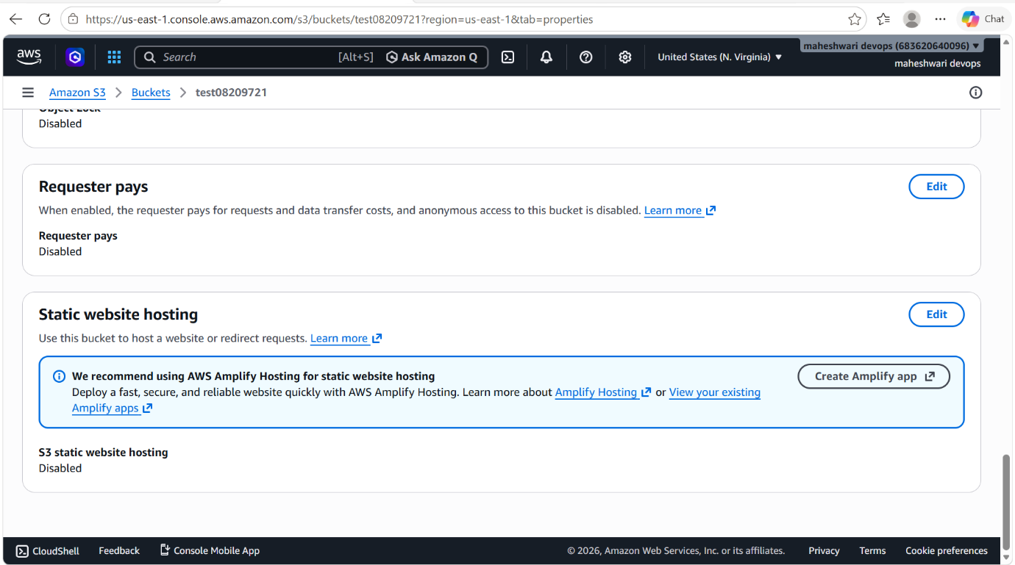

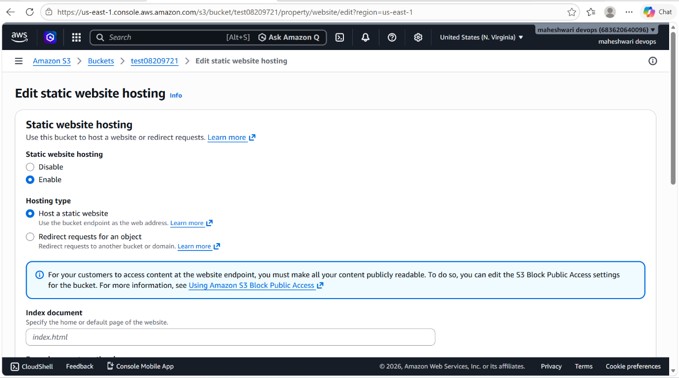

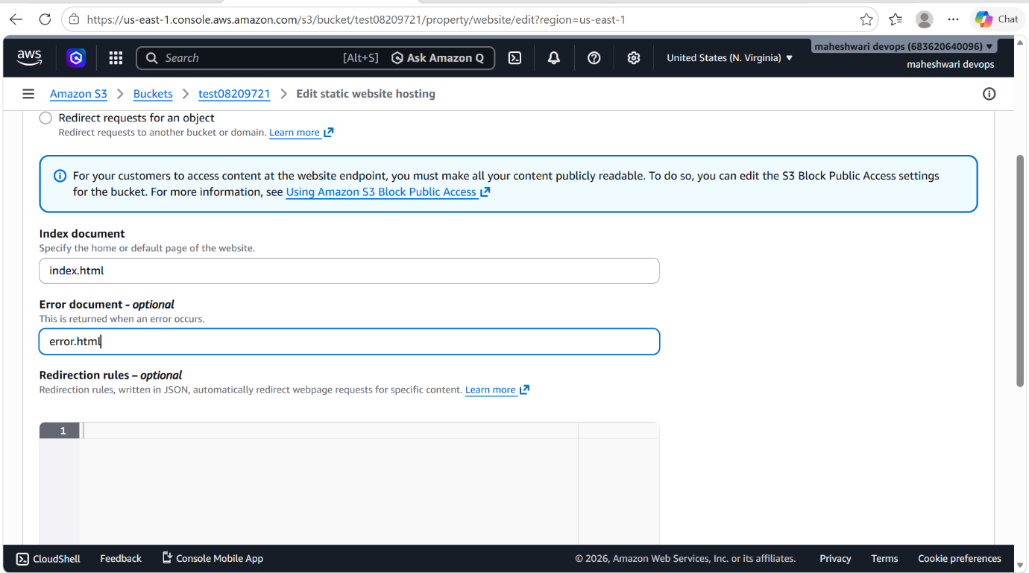

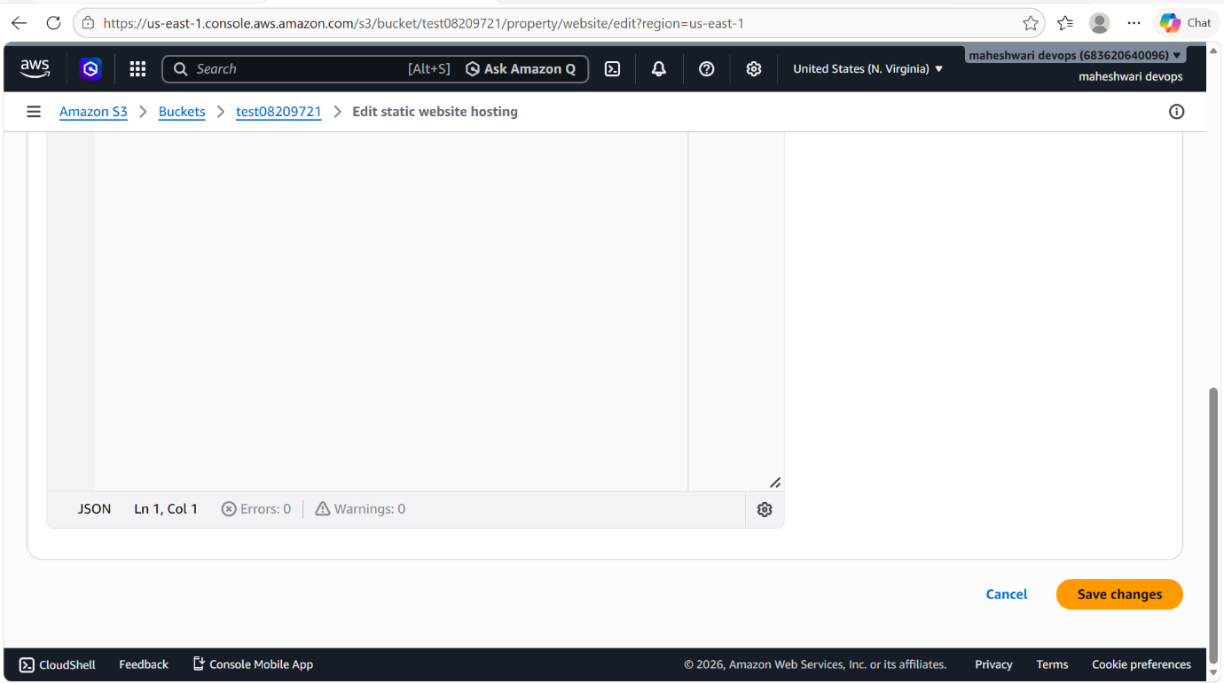

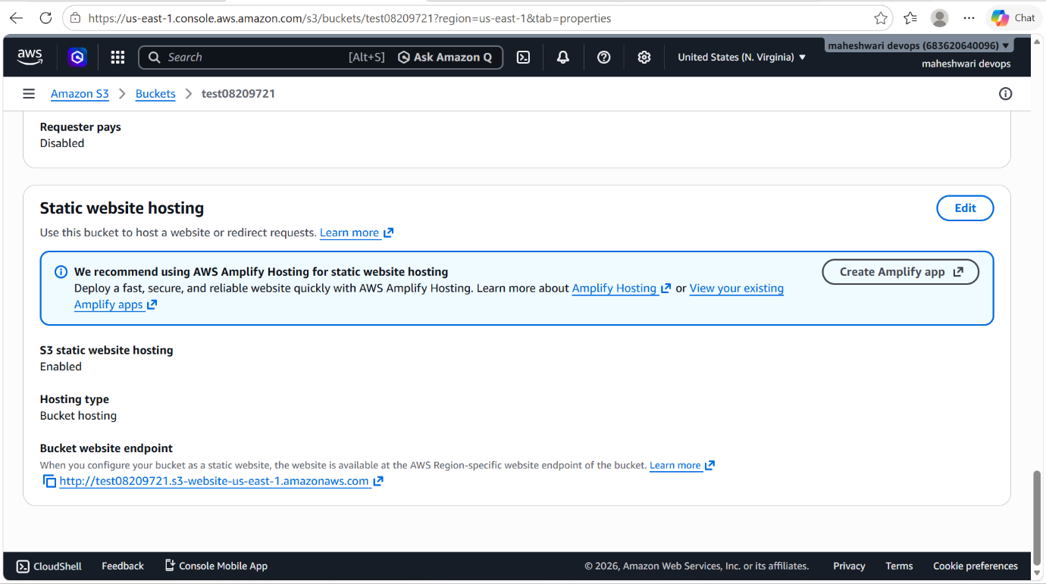

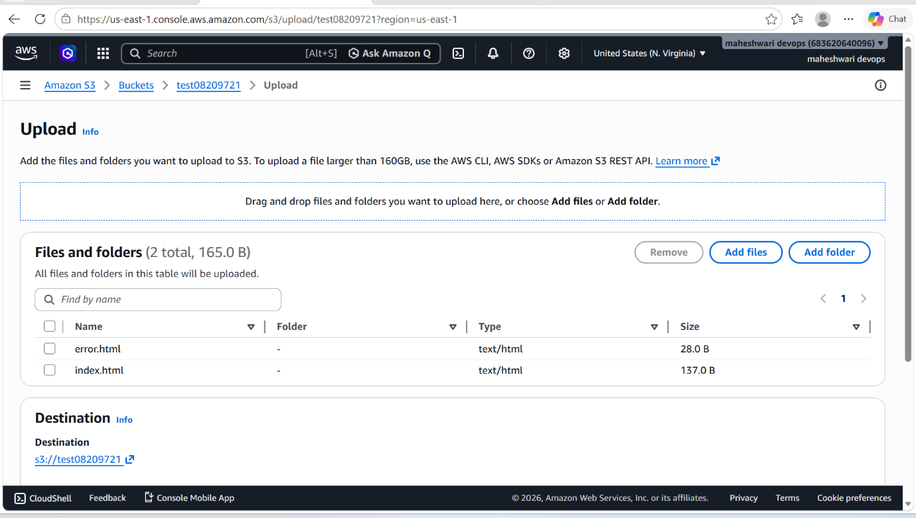

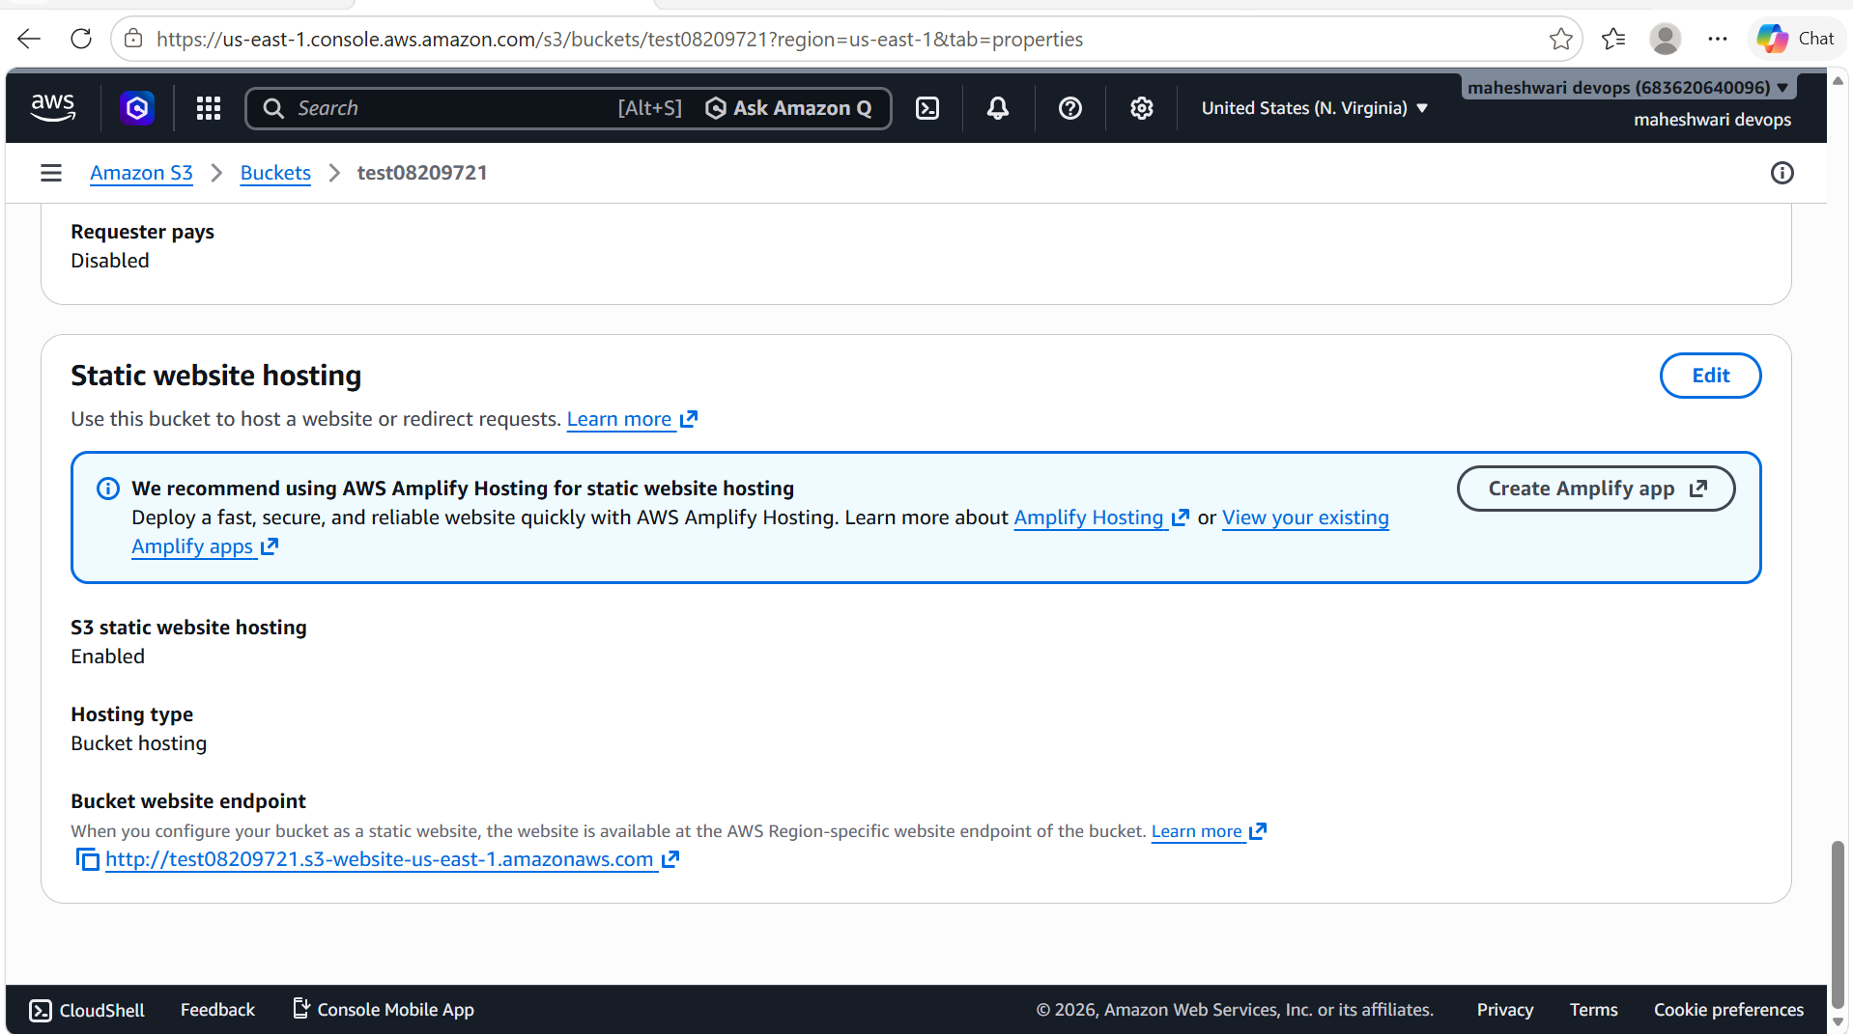
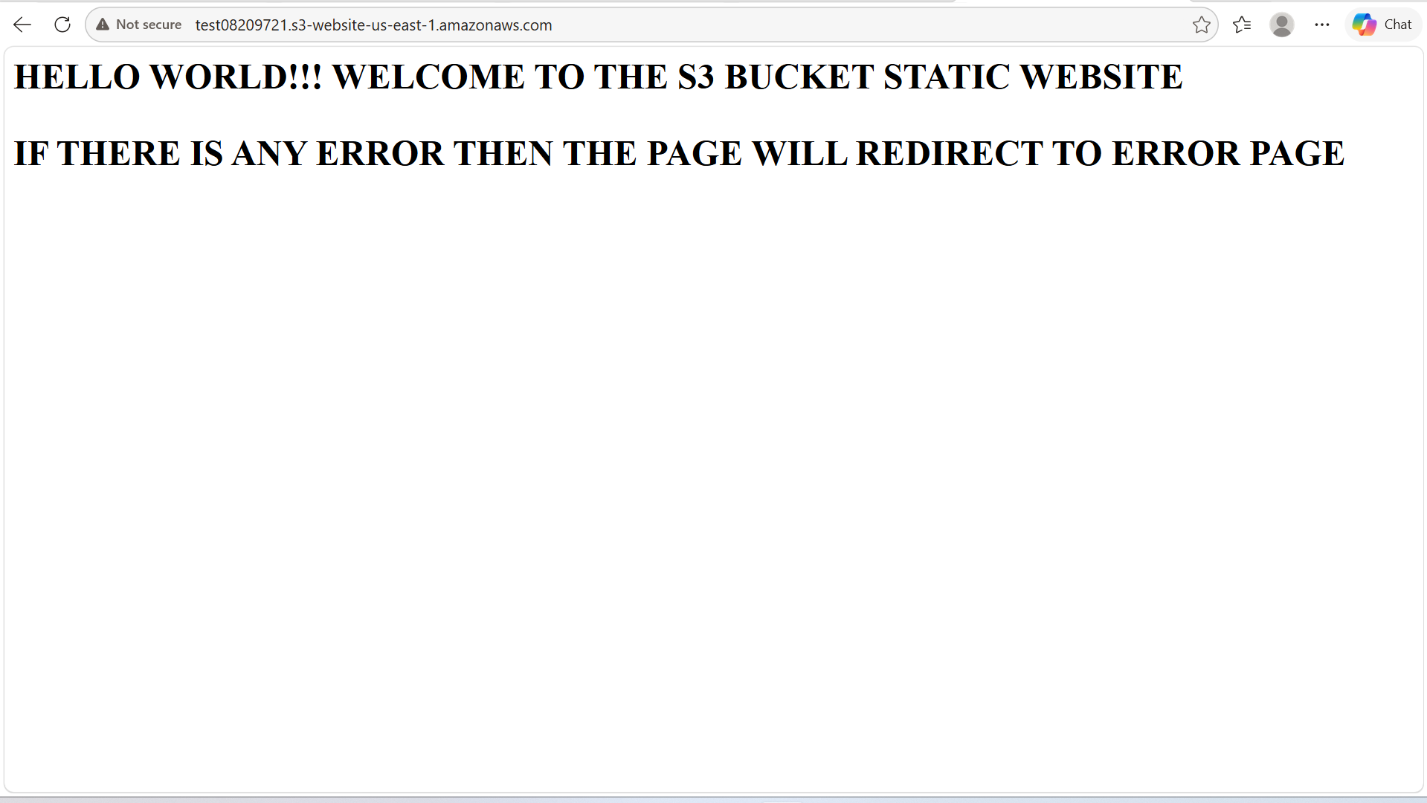

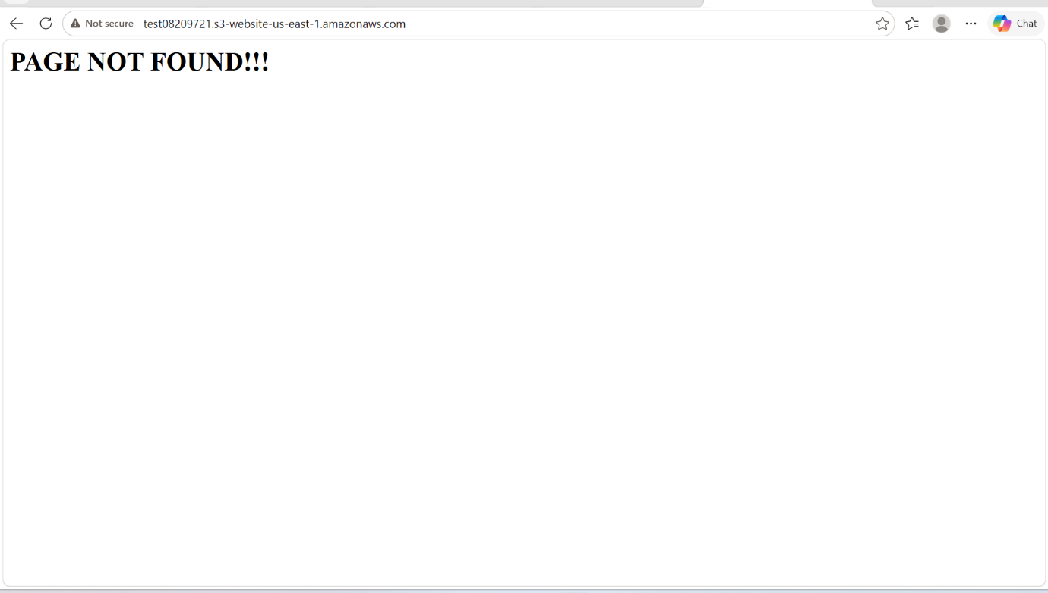

3. Enable cross-region replication on S3 buckets

PURPOSE: Enable cross-region replication on an Amazon S3 bucket means automatically copying objects from one S3 bucket to another bucket in a different AWS region.

OBJECTIVE: Enable S3 Cross-Region Replication to maintain a geographically separate copy of data for disaster recovery and business continuity.

OUTCOME: Critical S3 data is continuously replicated to a secondary AWS region, improving resilience, disaster recovery readiness, data availability and protection against regional failures.

STEP BY STEP IMPLEMENTATION:
- create a new bucket in other region.
- To copy all the files from one region to other region will use cross-region replica.
- In the management pane, create a new replica
- Give a name to that replica rule.
- Add the destination bucket name.
- Enable the encryption.
- Click on create and it will create replication of the source bucket.
- These all process should be done in the source bucket.

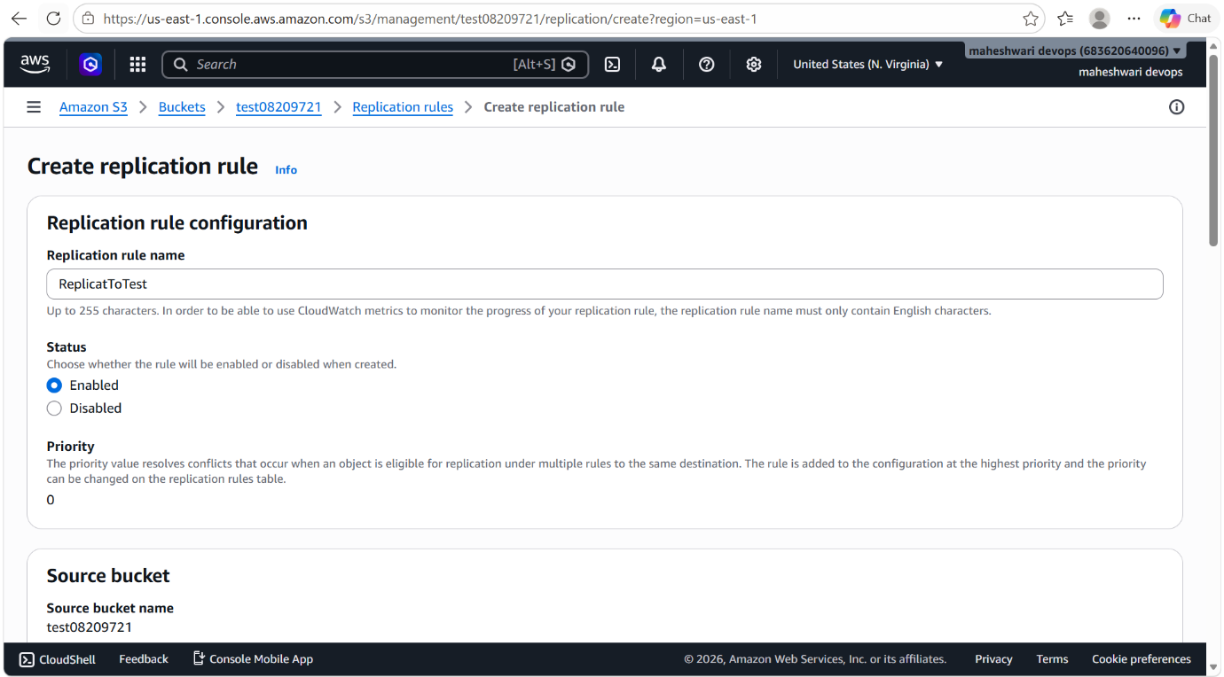

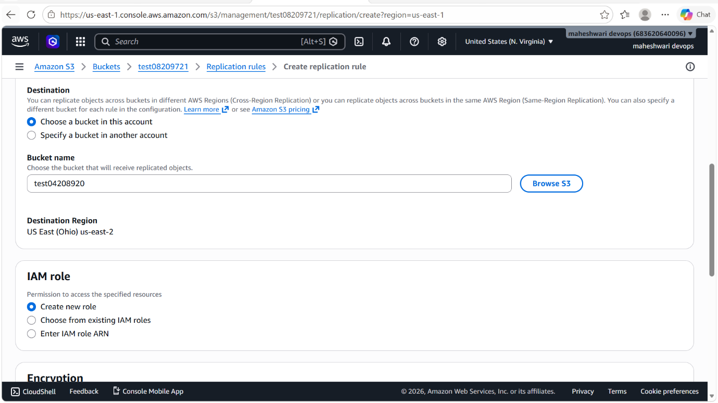

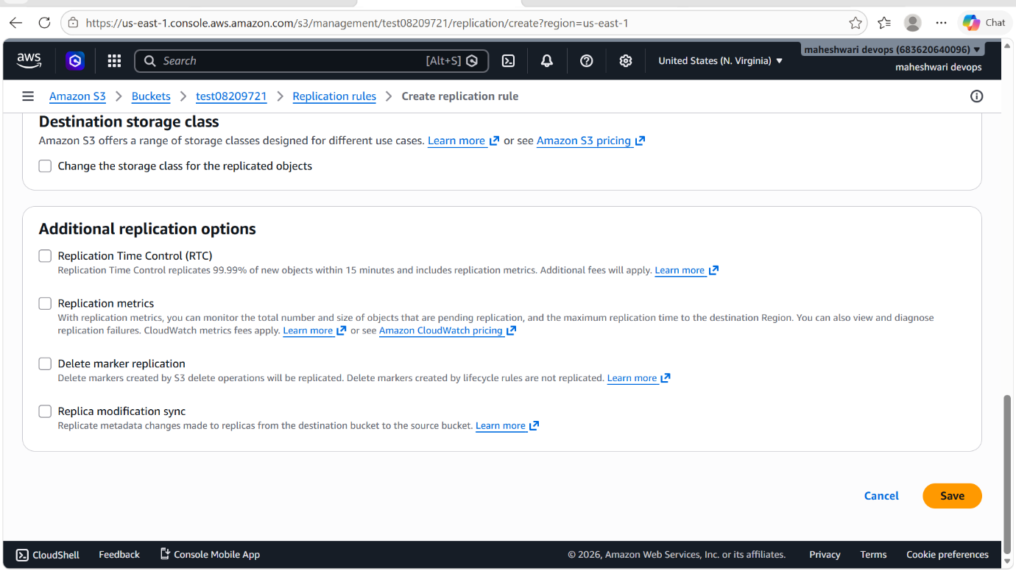

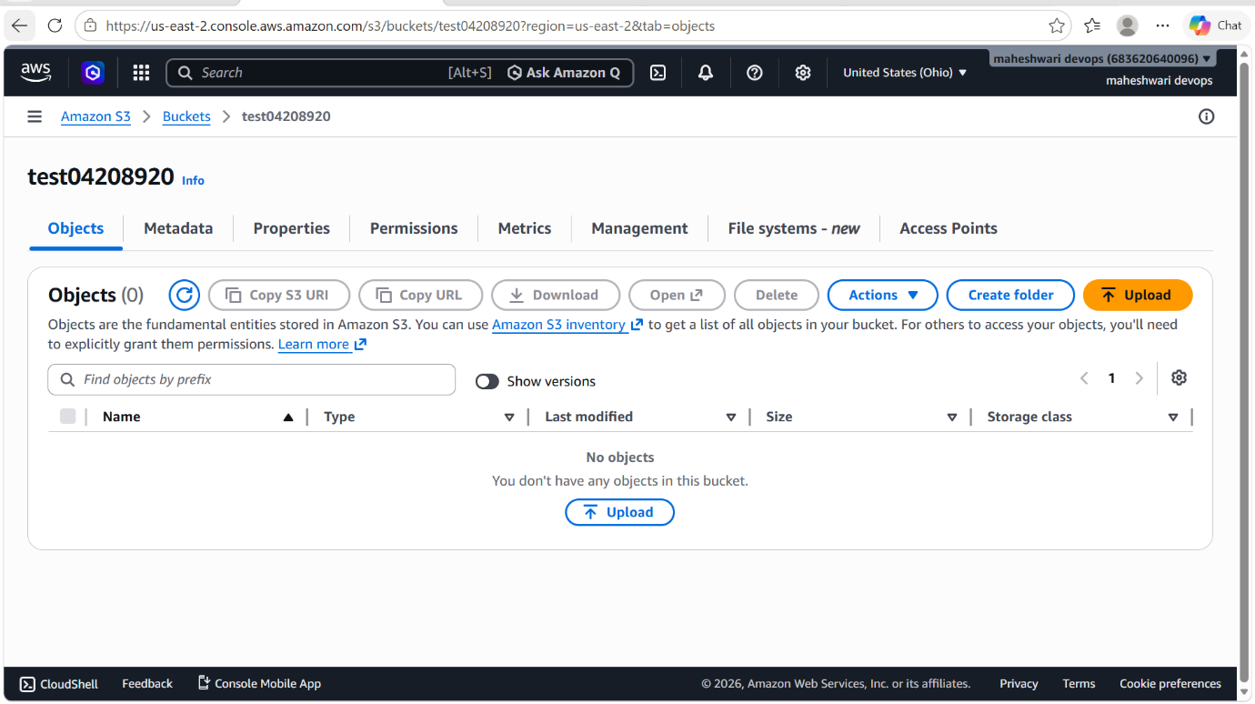

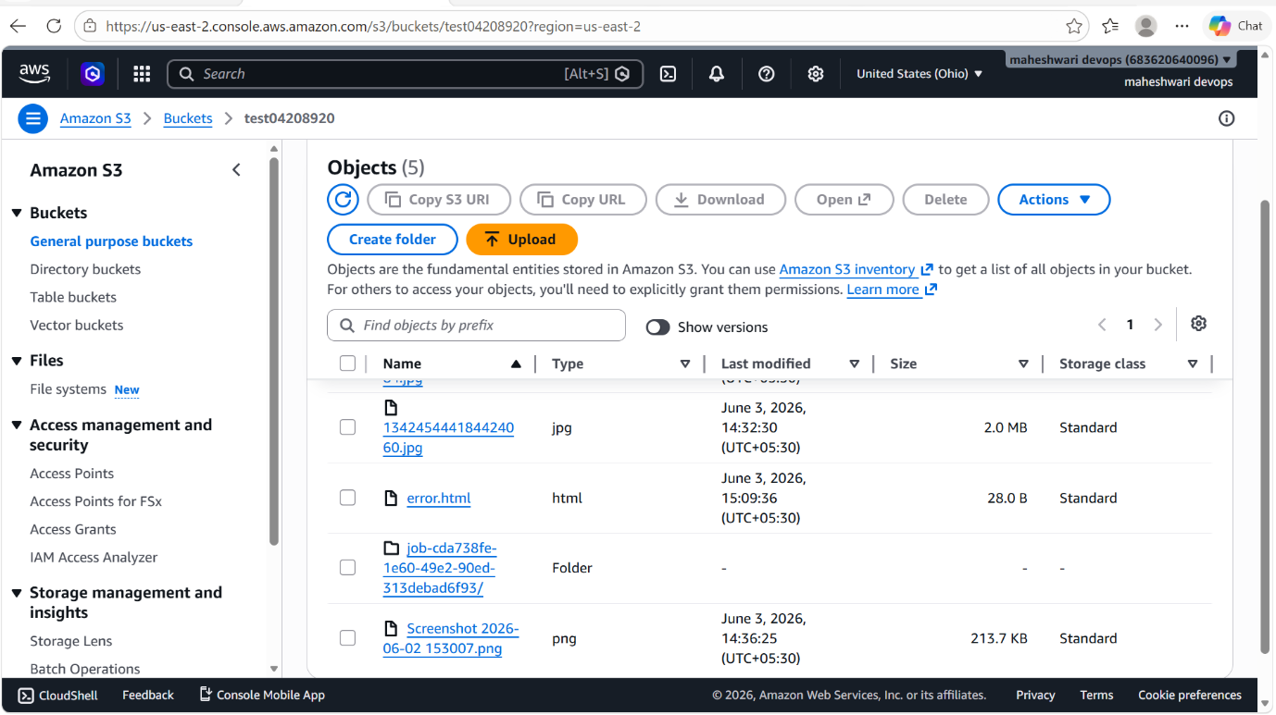

4. Configure a bucket policy so only the Admin user can see the objects of the S3 bucket.

PURPOSE: Restrict S3 bucket object visibility to the Admin user only, ensuring secure and controlled access to stored data.

OBJECTIVE: Restrict access to S3 bucket objects exclusively to the Admin user to enhance data security and access governance.

STEP BY STEP IMPLEMENTATION:
- Go to S3 bucket service and add a bucket policy to a particular bucket.
- To add a bucket policy, go to the permissions tab and add a bucket policy there.
- After adding bucket policy to the S3 create a admin user in the IAM users tab.
- Give the name that as admin and policy to be attached is complete administrator access.
- Now we can have that buckets of S3 in IAM admin user.

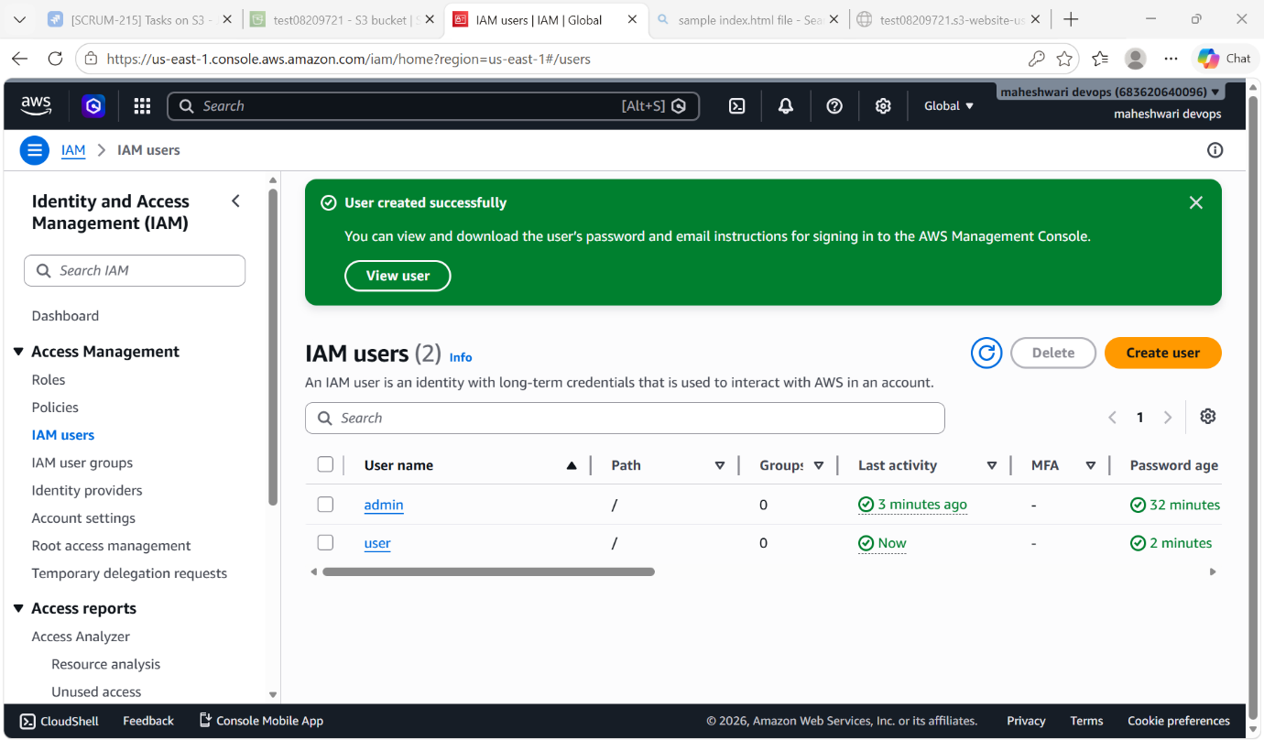

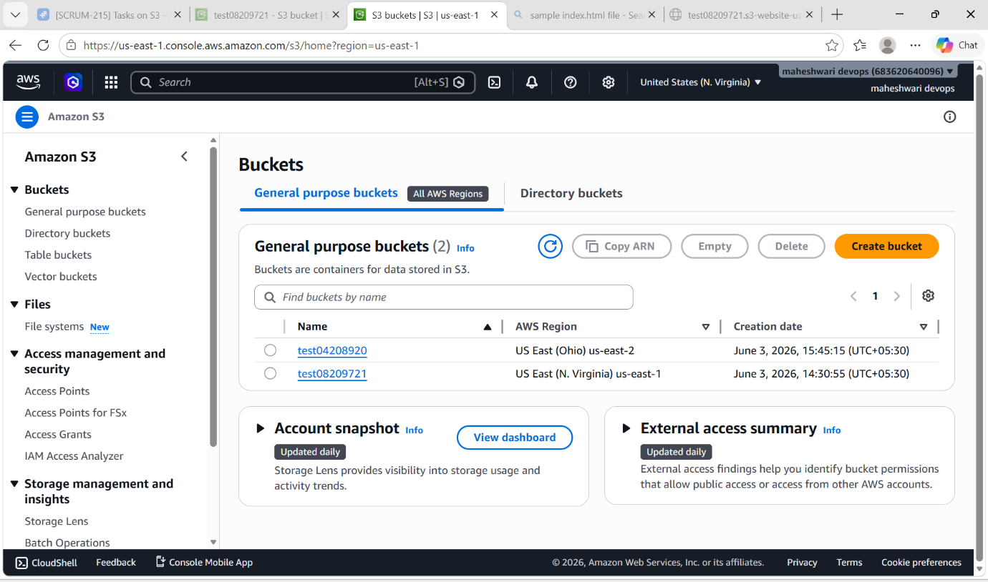

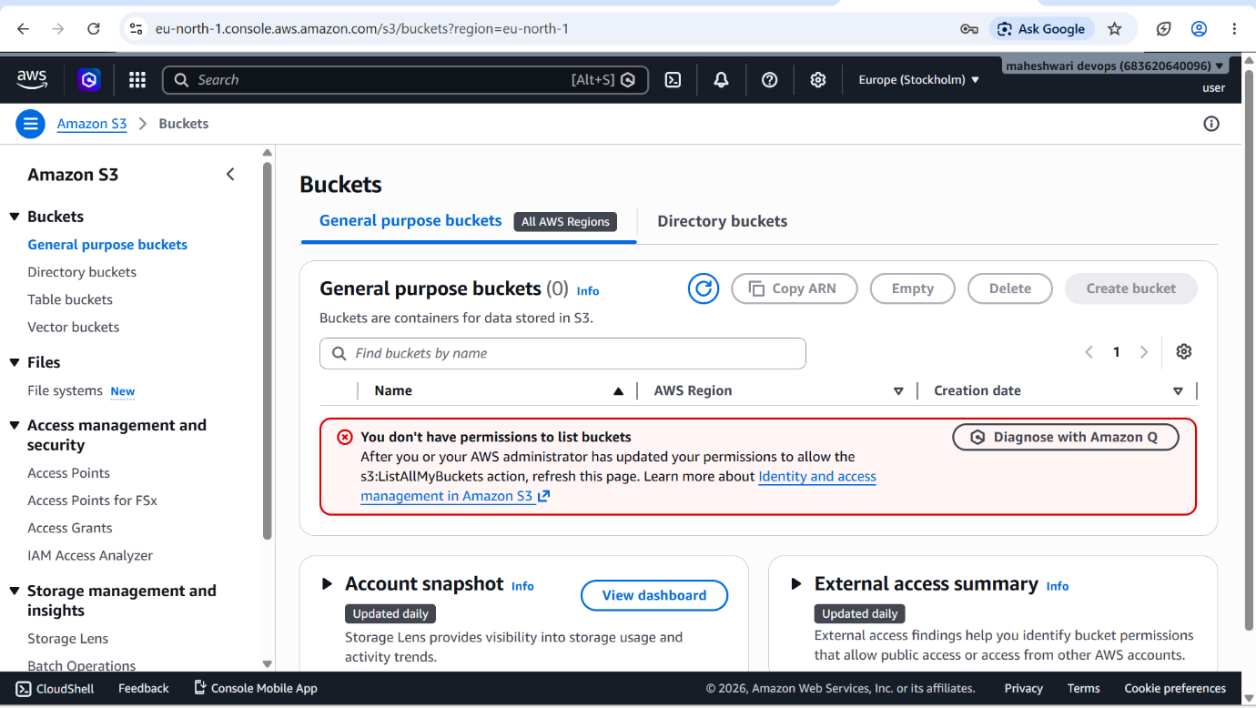

5. Set up lifecycle policies to automatically transition or delete objects based on specific criteria.

PURPOSE: The purpose of setting up lifecycle policies in Amazon S3 is to automate the management of object storage throughout its lifecycle, helping reduce storage costs and simplify data retention management.

OBJECTIVE: To configure Amazon S3 Lifecycle Policies that automatically transition or delete objects based on defined criteria, thereby optimizing storage costs, enforcing data retention requirements, and reducing manual management efforts.

OUTCOME: Successfully implemented Amazon S3 Lifecycle Policies to automate object transition and deletion processes, resulting in cost optimization, improved storage management, and adherence to data retention policies.

STEP BY STEP IMPLEMENTATION:
- Go to S3 service in AWS.
- In S3 service, select the target bucket.
- In the target bucket, open the management tab.
- Under Lifecycle rules, click create lifecycle rule.
- Enter a rule name and choose the scope of the rule select apply to all objects in the bucket.
- Configure lifecycle actions:
-> Transistion current versions of objects to another storage class after a specified number of days.
-> Expire current versions of objects after a specified number of days.
-> Optionally manage non-current versions and incomplete multipart uploads.
- Specify transition details. Example:
-> move objects to S3 Standard-IA after 30 days.
-> move objects to S3 Glacier Flexible Retrieval after 90days.
- Specify expiration details. Example:
->Delete objects after 365 days.
- Review the configuration and click on create rule.

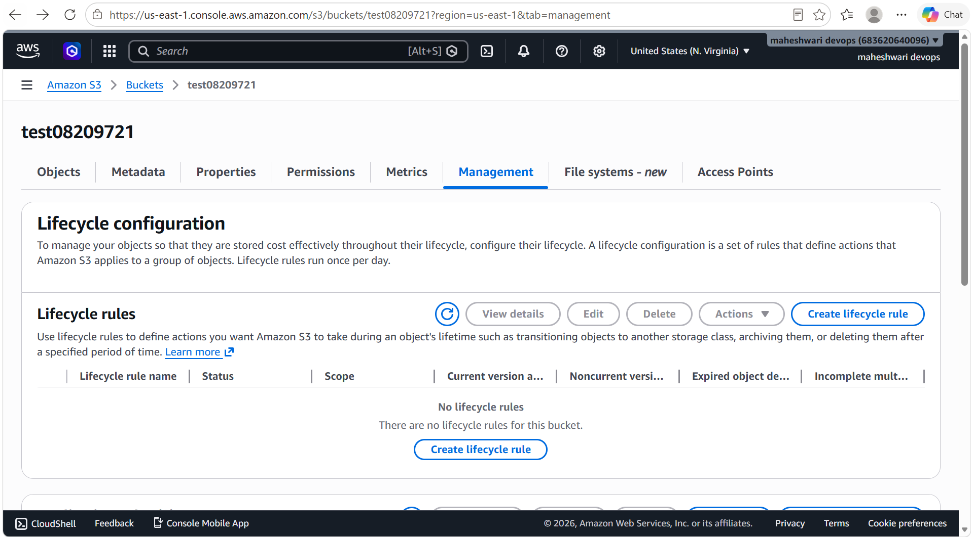

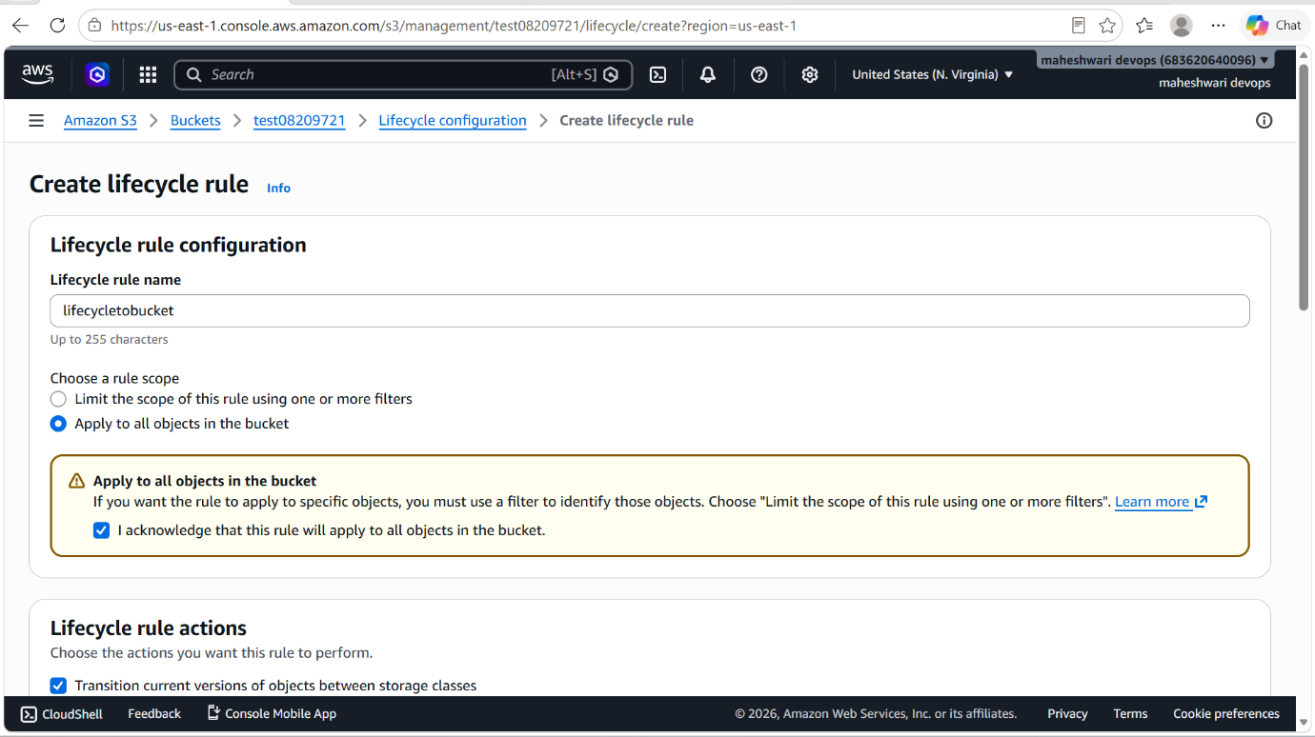

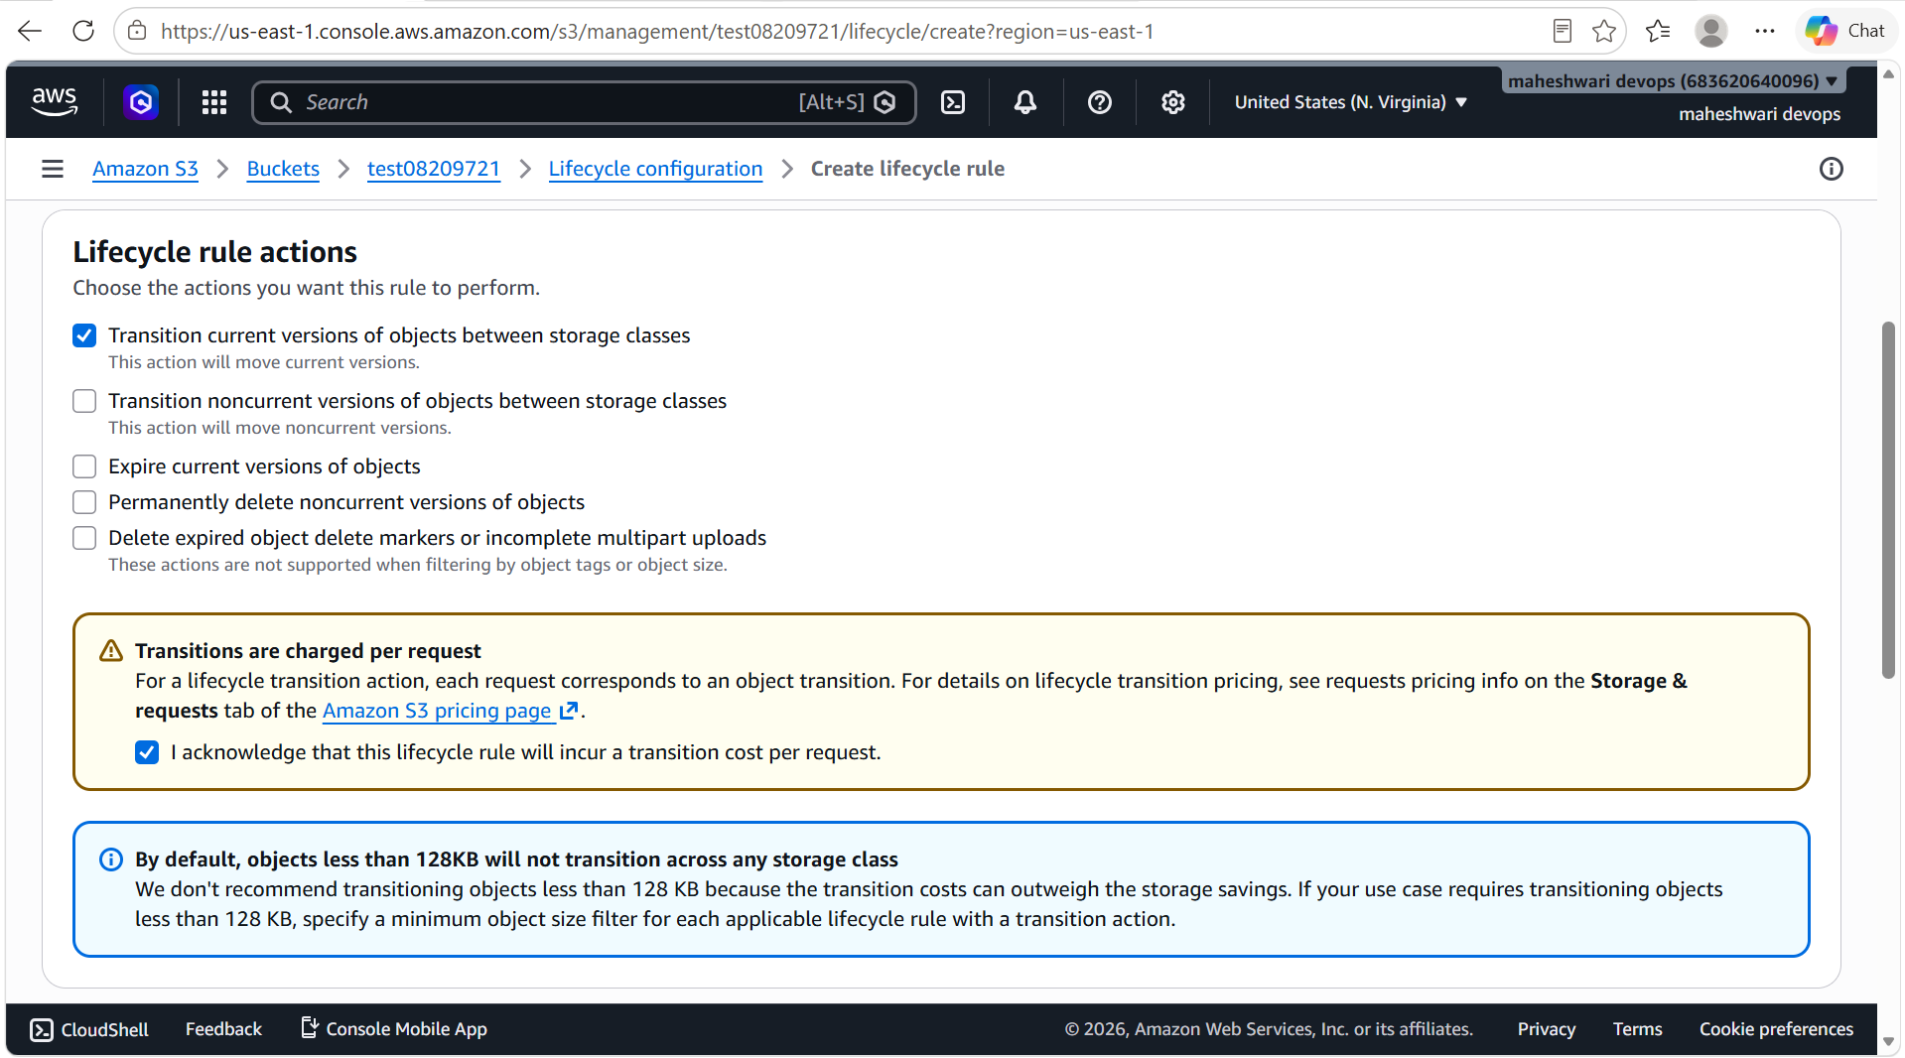

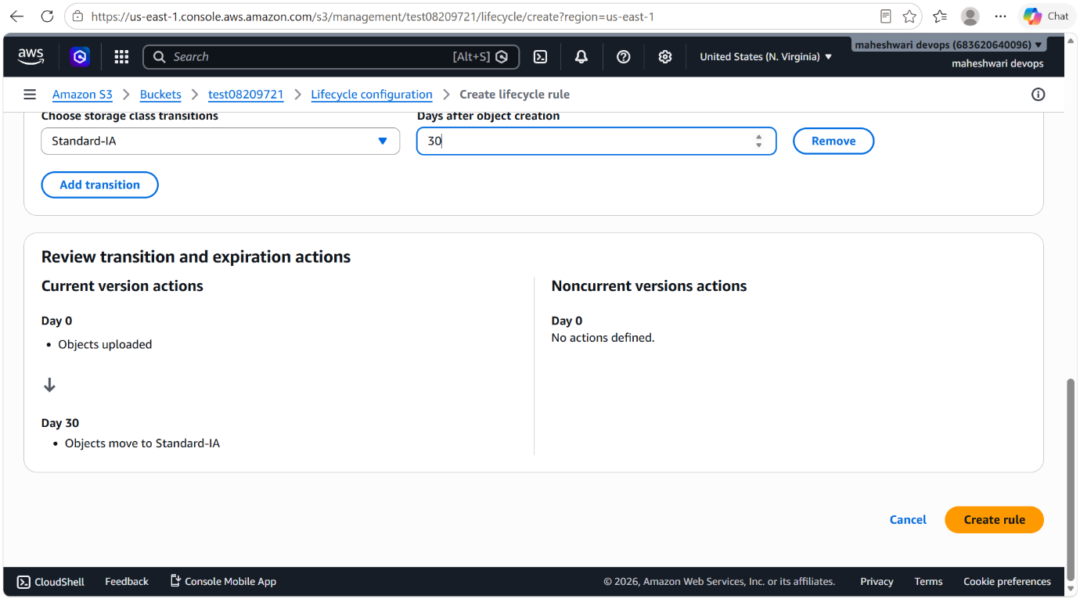

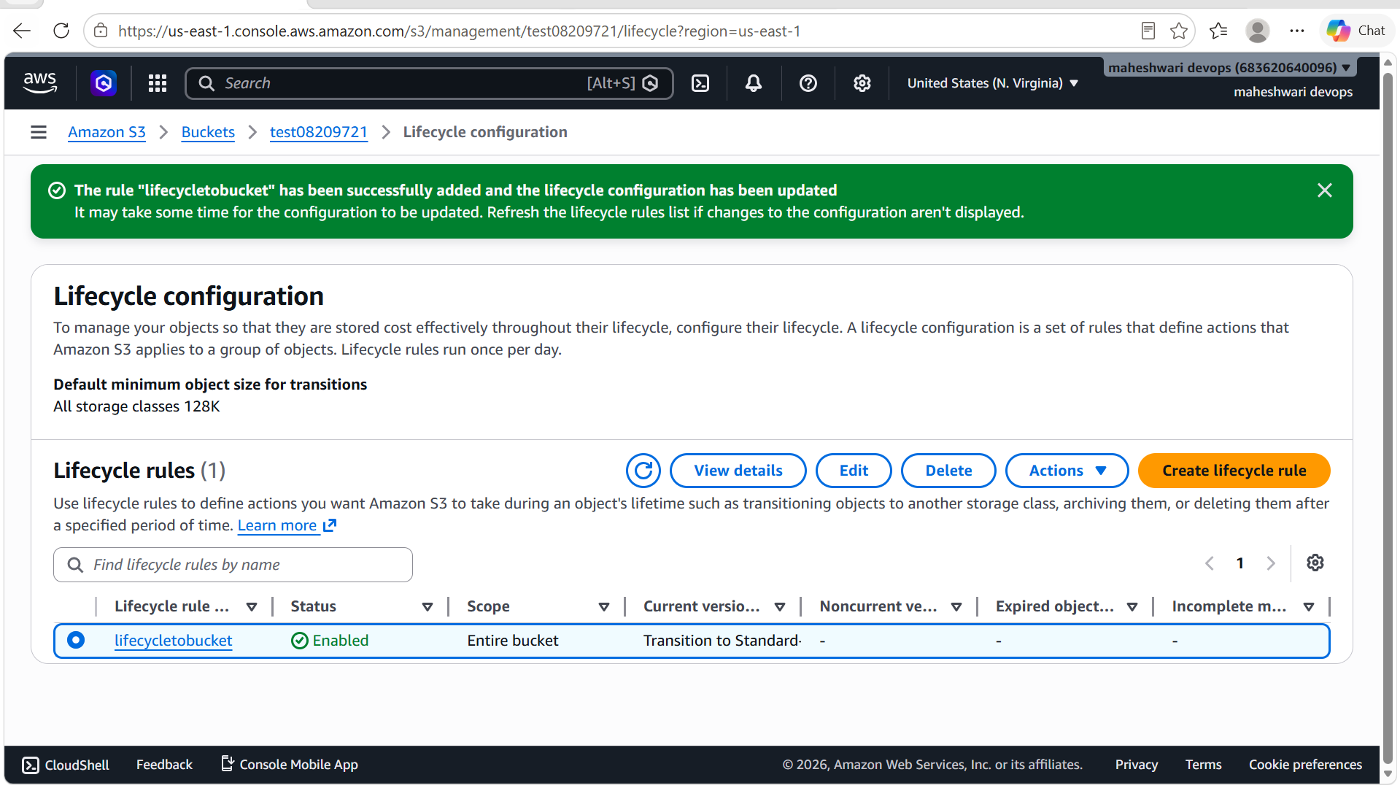

6. Push some objects to S3 using the AWS CLI.

PURPOSE: The purpose of pushing objects to Amazon S3 using the AWS CLI is to upload files and data to an S3 bucket efficiently through command -line operations, enabling automation, scripting and streamlined cloud storage management.

OBJECTIVE: To use the AWS CLI to upload objects from a local system to an Amazon S3 bucket, enabling efficient, automated, and scalable management of cloud storage resources.

OUTCOME: Successfully uploaded objects to an Amazon S3 bucket using the AWS CLI, enabling efficient cloud storage management, automated file transfers, and secure data storage in Amazon S3.

STEP BY STEP IMPLEMENTATION:
- Go to git bash, in git bash we have to configure the AWS CLI
- We have to execute the command aws configure
- By executing this command, CLI will ask for secret access id and secret access key.
- After configuration, now create a bucket in the S3 by the command -> aws s3 mb s3://<bucket-name>
- To verify whether the bucket is created or not by the command -> aws s3 ls
- To push the objects from local to S3 -> aws s3 cp "<filepath>" s3://test04208921/ --recursive
- To view the objects of the bucket -> aws s3 ls s3://<bucket-name>/

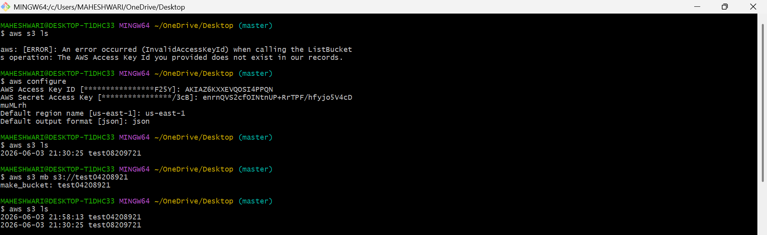

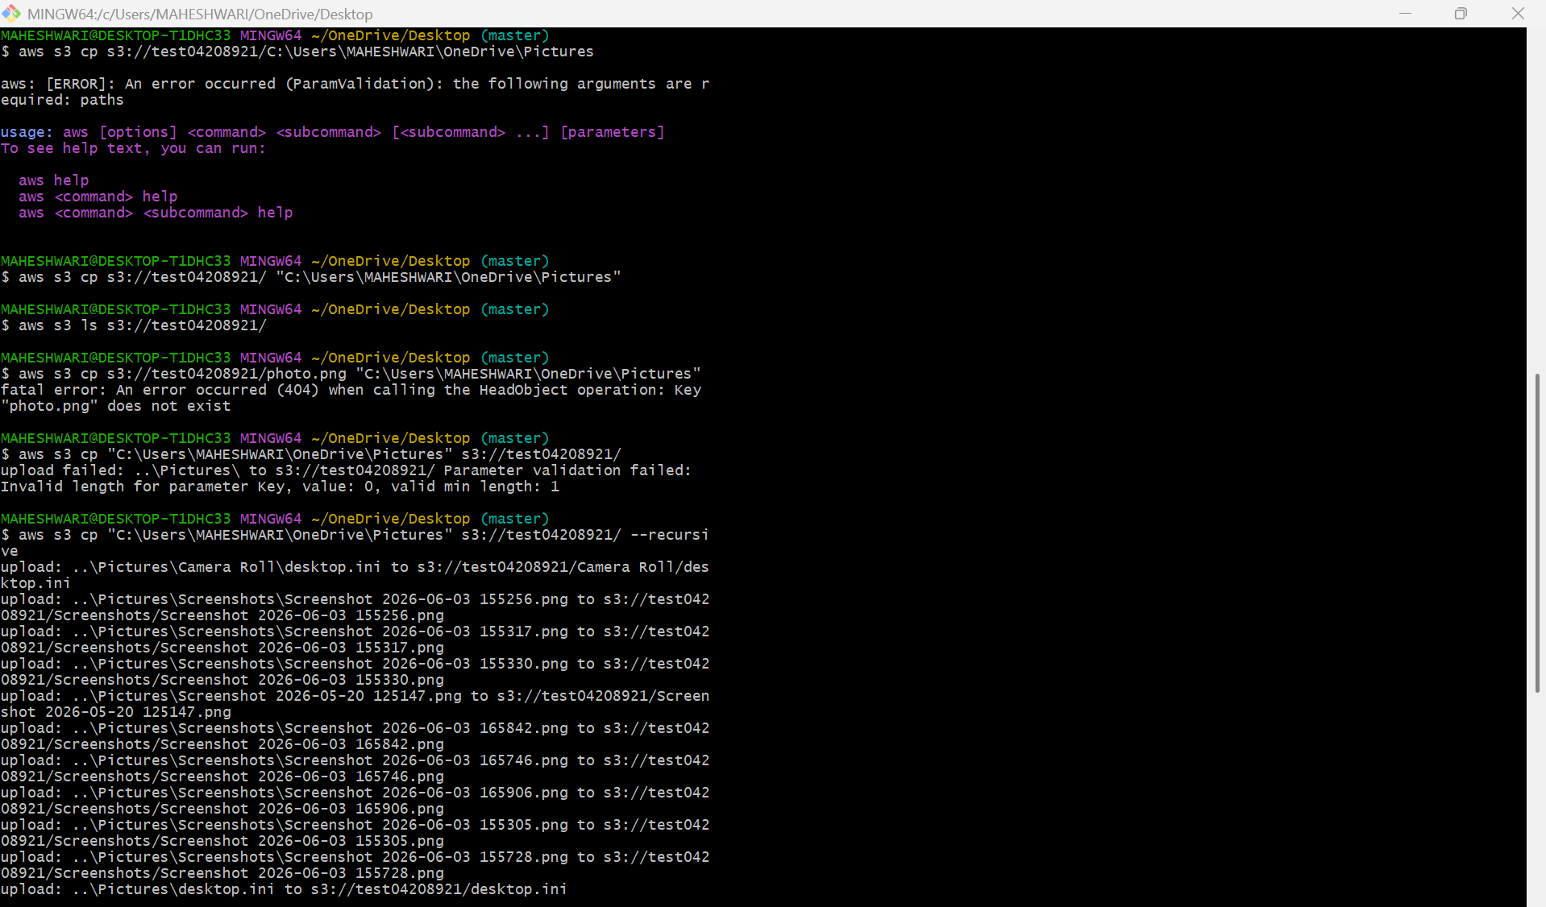

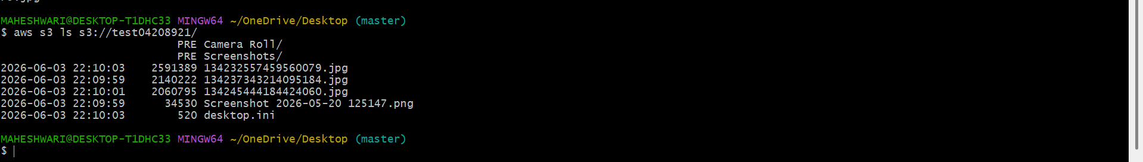

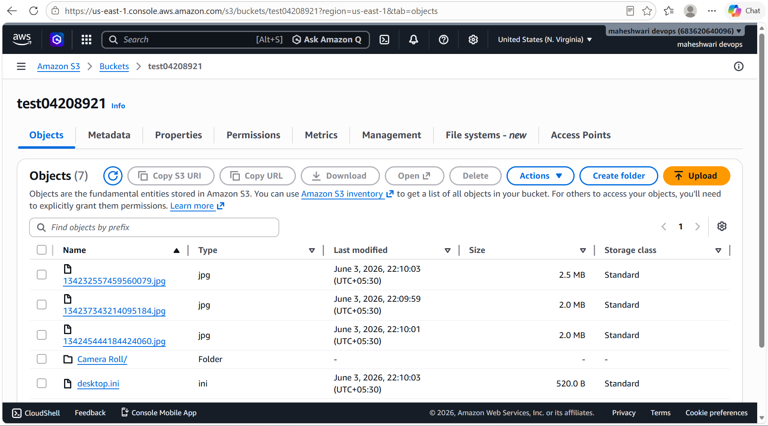

7. Write a Bash script to create an S3 bucket

PURPOSE: The purpose of writing a Bash script to create an Amazon S3 bucket is to automate the bucket creation process, ensuring consistency, reducing manual effort, and enabling efficient clud resource provisioning.

OBJECTIVE: To develop and execute a Bash script that automatically creates an Amazon S3 bucket using AWS CLI commands, ensuring efficient, consistent, and repeatable cloud resource provisioning.

OUTCOME: Successfully developed and executed a Bash script to create an Amazon S3 bucket, resulting in automated, consistent, and efficient cloud resource provisioning while reducing manual effort and configuration errors.

STEP BY STEP IMPLEMENTATION:
- Open git bash and configure the AWS CLI.
- In CLI, create a script to create a s3 bucket.
- When u run the script, it will ask for the bucket name that you want to give.
- After this it will create a bucket with the given name that you have given.

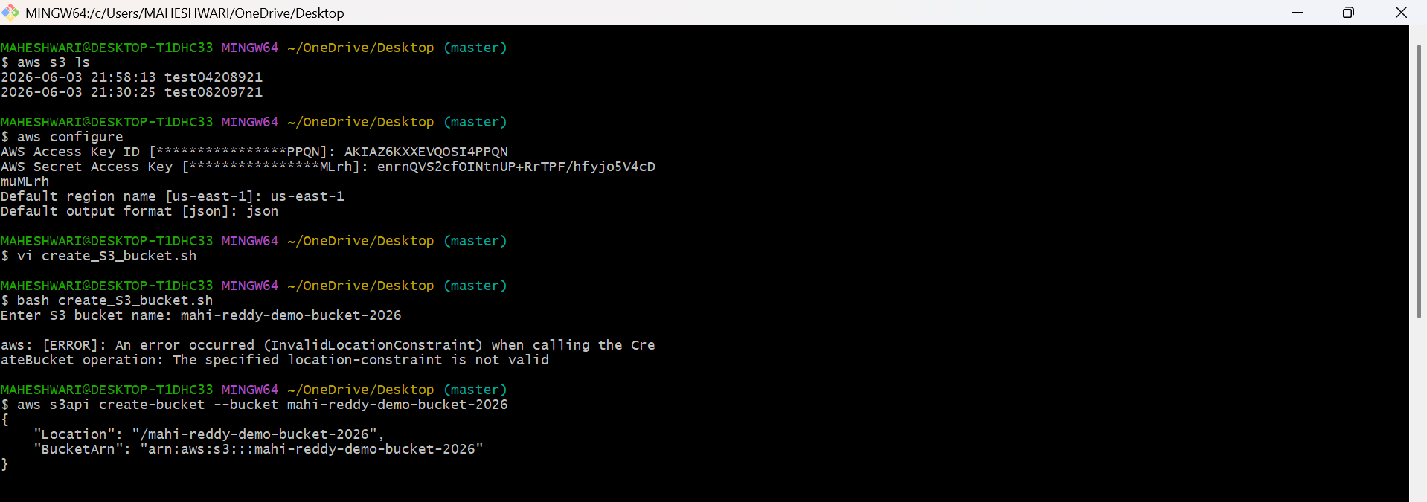

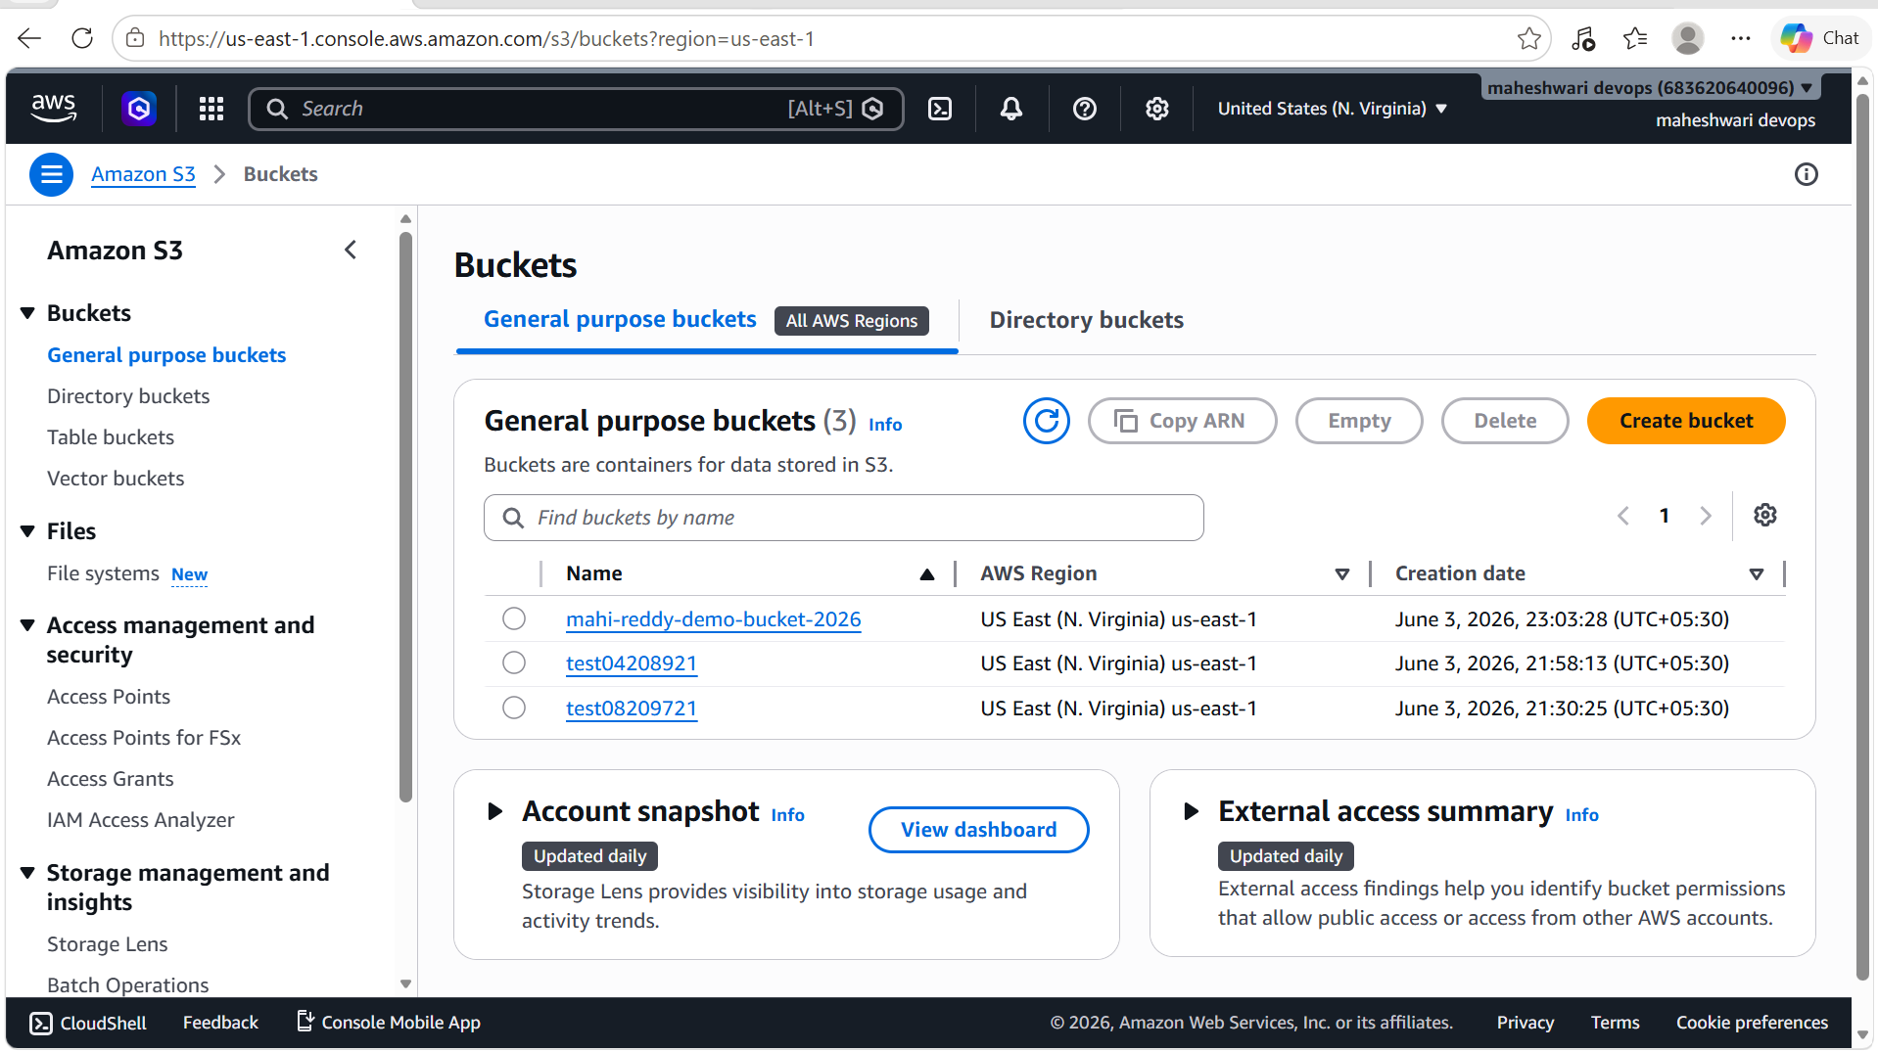

8. Upload a 1 GB file to S3 using the CLI.

- First of all, create a 1GB file by AWS CLI by the command ->
dd if=/dev/zero of=testfile_1GB.bin bs=1M count=1024
- To verify the file size by the command -> ls -lh testfile_1GB.bin
- After this copy this created 1GB file to the remote bucket in S3 service in AWS.
- Now go and verify in the AWS console.

